**Creating, Deploying and Running a Simple ADF Mobile Browser Application**

**Introduction**

This document lists the various steps required to develop a simple browser based application for blackberry cell phones using Oracle ADF and Jdeveloper.

**Technology Overview**

Oracle’s Application Development Framework (**ADF**) now ported to mobile devices in a client format. It is divided into two parts

**ADF Mobile Browser**

Oracle ADF Mobile Browser Applications for a connected Web application running in the mobile device’s browser. It develops application once, and delivers mobile optimized content to all devices.

**ADF Mobile Client**

ADF Mobile Client Applications for a disconnected application running on the mobile device leveraging device-native UI components.

**PART 1: Creating the ADF mobile browser application**

* 1. Creating a new application containing the required technology scope.

1. Click on ‘File’ menu and click on ‘New’.

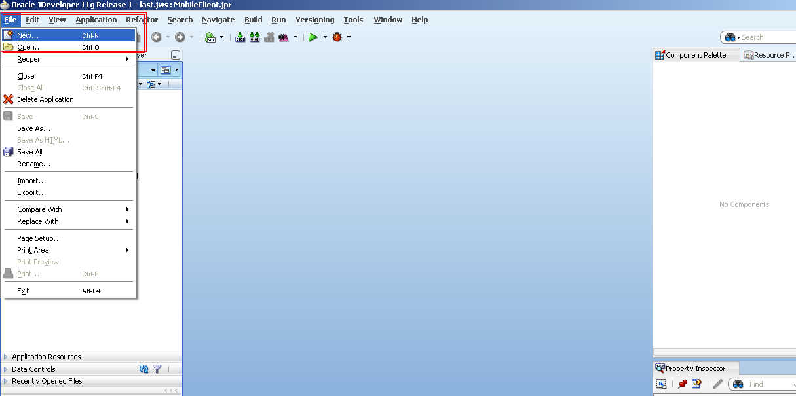

1. Select ‘Applications’ from the left pane in the ‘Current Project Technologies’ tab and then select ‘Fusion Web Application (ADF)’. Click OK.

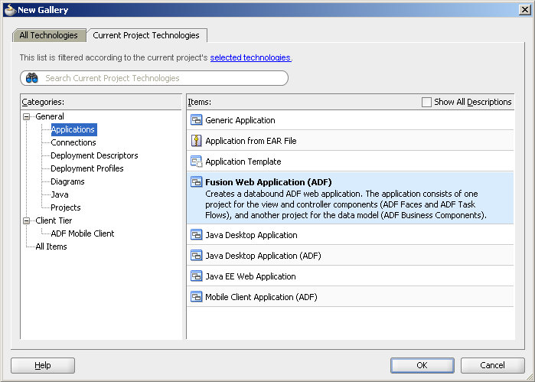

1. Name the new application to be created as ‘DemoApp’. You will notice that the Directory field also changes accordingly. Click ‘Next’.

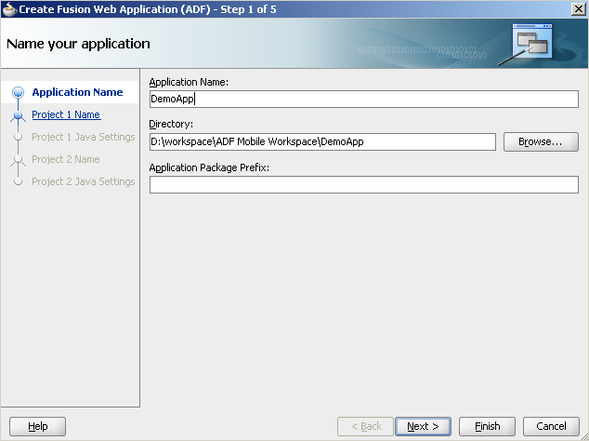

1. Accept the default (Ensure that the Project Technologies have ‘ADF Business Components’ and ‘Java’ selected) and click on ‘Next’.

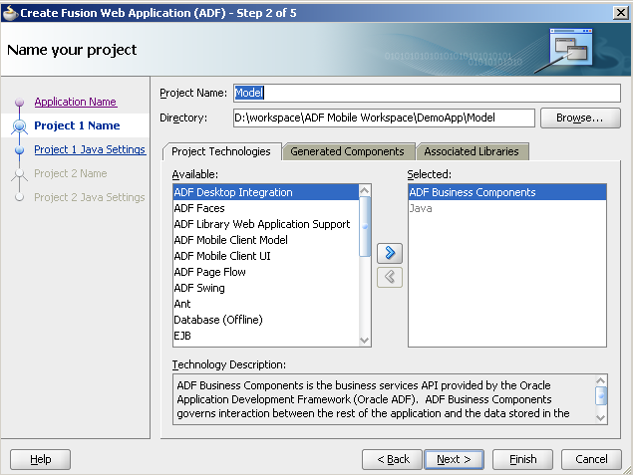

1. Accept the default and click ‘Next’.

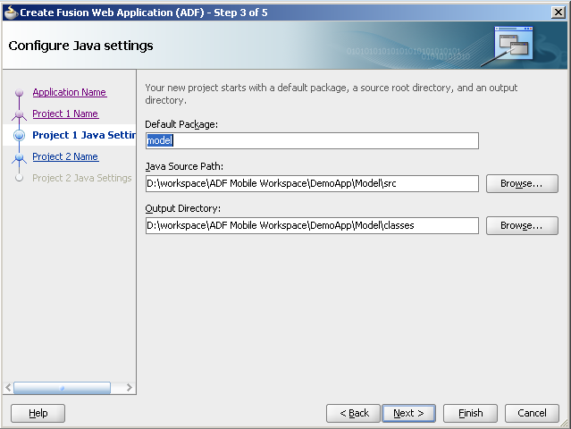

1. Ensure that the Project Technologies have ‘ADF Faces’, ‘ADF Page Flow’, ‘HTML’, ‘Java’, ‘JSF’, ‘JSP and Servlets’, ‘XML’ selected. Shuttle the ‘Mobile Browser’ from the Available pane to the Selected pane.

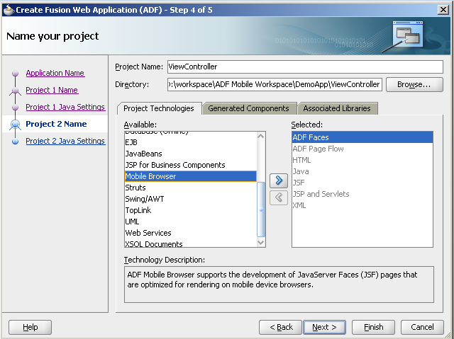

1. ‘Mobile Browser’ would now appear in the Selected pane. Click ‘Next’.

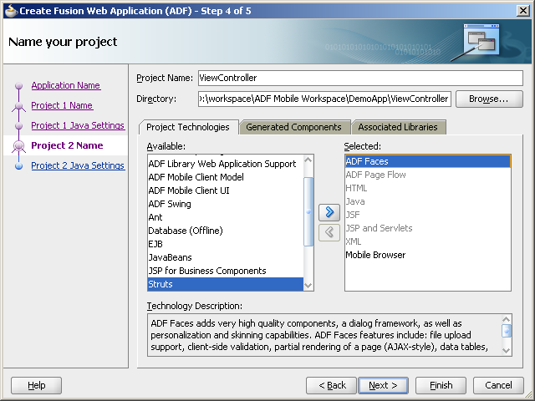

1. Accept the default and click ‘Finish.

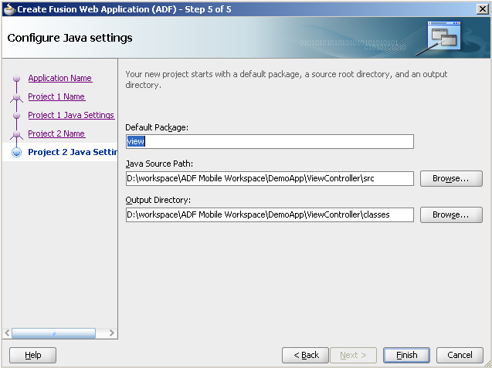

1. A new application has been created. At the left is the Application Navigator containing the application file structure.

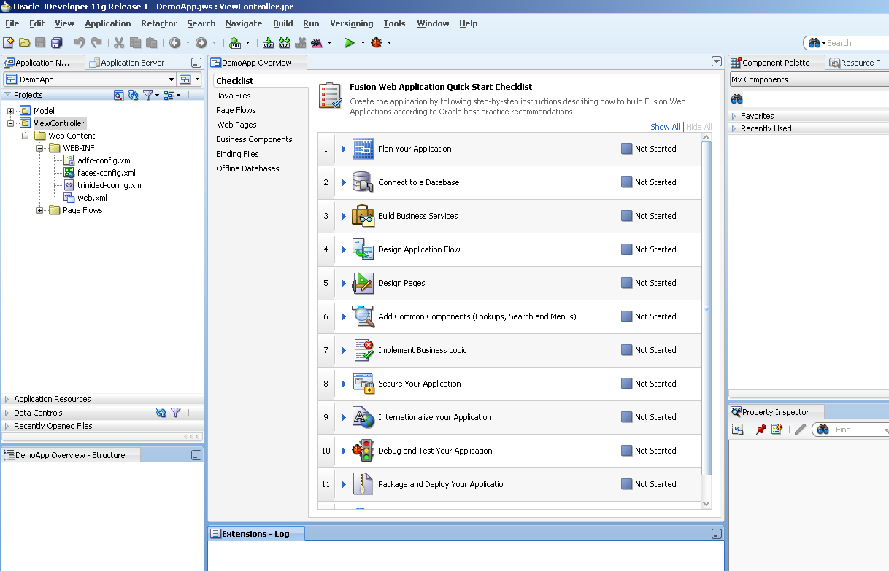

* 1. Creating the business components for handling data.

1. Right click on ‘Model’ and click on ‘New’.

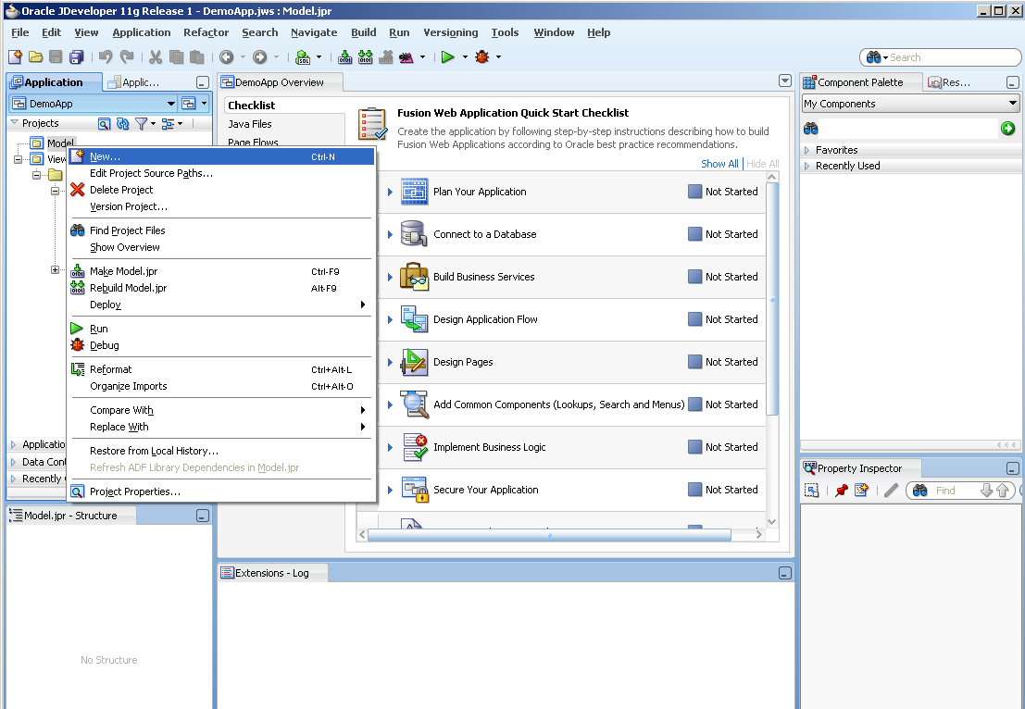

1. In the ‘New Gallery’ box, select ‘ADF Business Components’ in the left pane in the ‘Current Project Technologies’ and select ‘View Object’. Click ‘OK’.

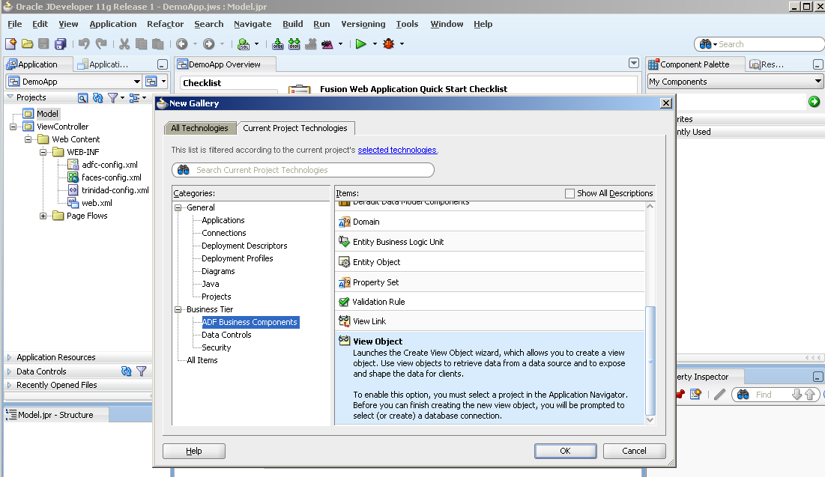

1. In the ‘Initialize Business Components Project’ box, click on ‘+’ symbol against the ‘Connection’ field to create a new connection to an existing database.

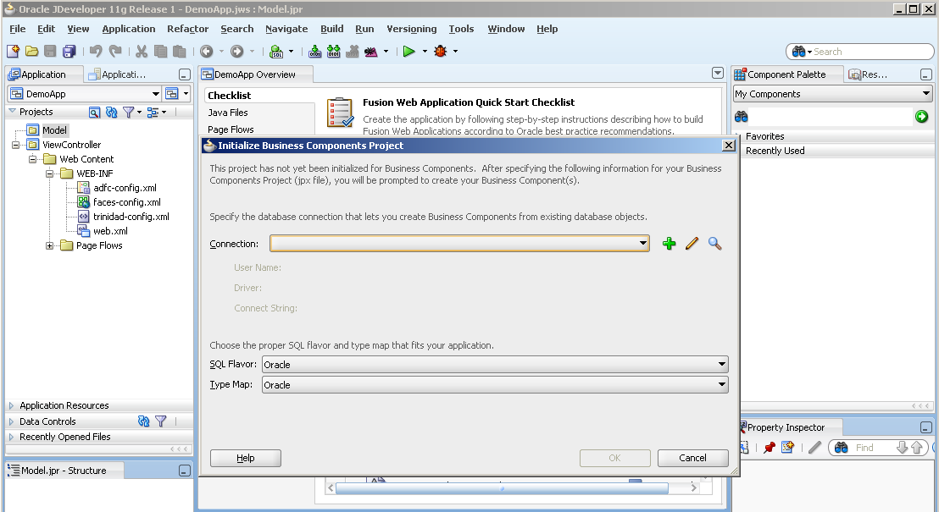

1. In the ‘Create Database Connection’ box, enter the database details, test the connection to be success and click ‘OK’.

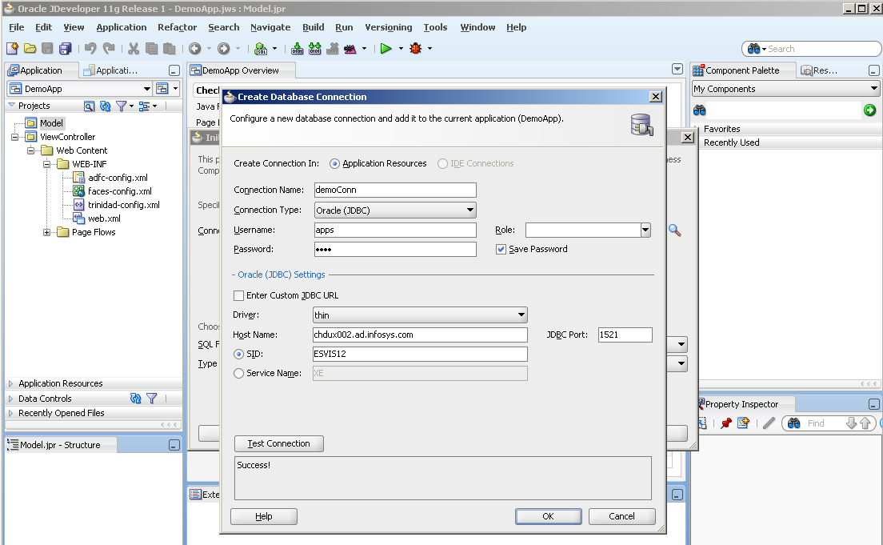

1. Back in ‘Initialize Business Components Project’ box, you see the connection created in the ‘Connection’ field and the details of the connection below that. Click ‘OK’.

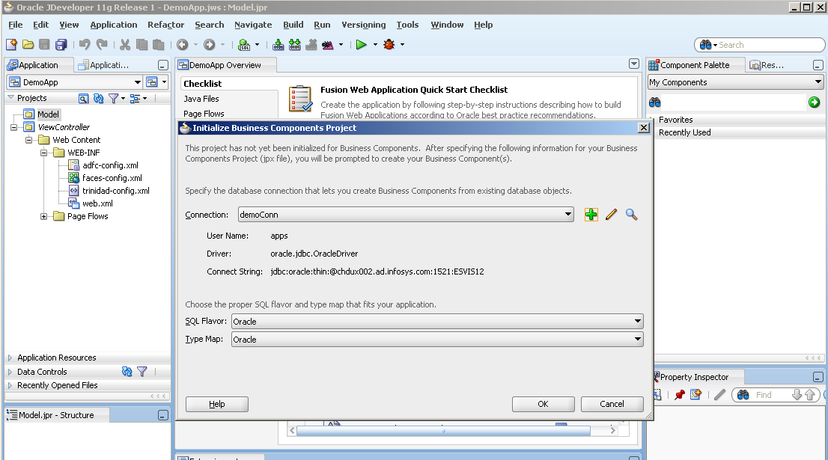

1. In the ‘Create View Object’ box, enter the name of view object in ‘Name’ field. For e.g., here we name it as ‘DemoView’. Click ‘Next’.

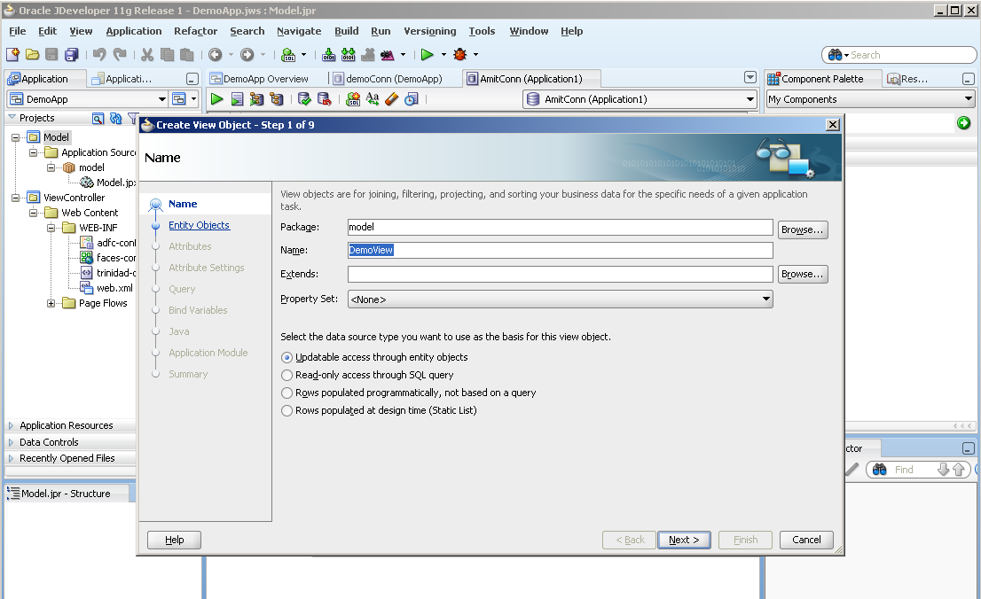

1. Click ‘Next’.

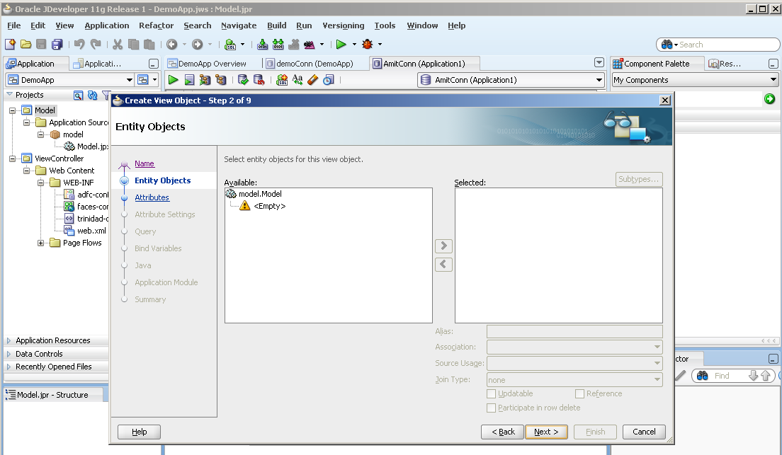

1. Click on ‘Next’.

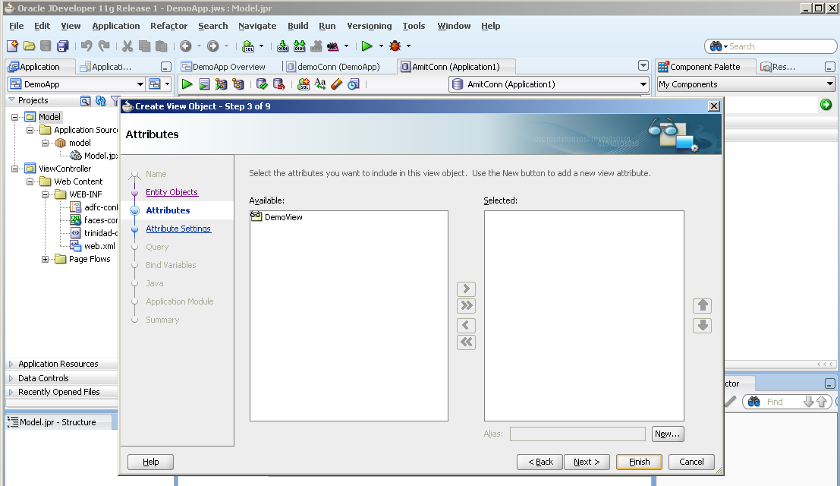

1. Click on ‘Next’.

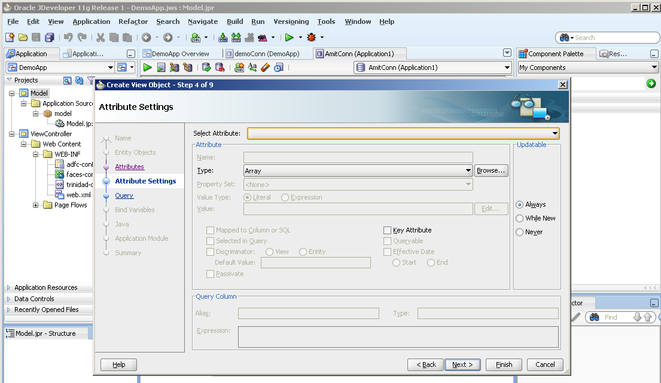

1. Enter the query for fetching the data from the database. Test the query. Click on ‘OK’ and then click ‘Next’.

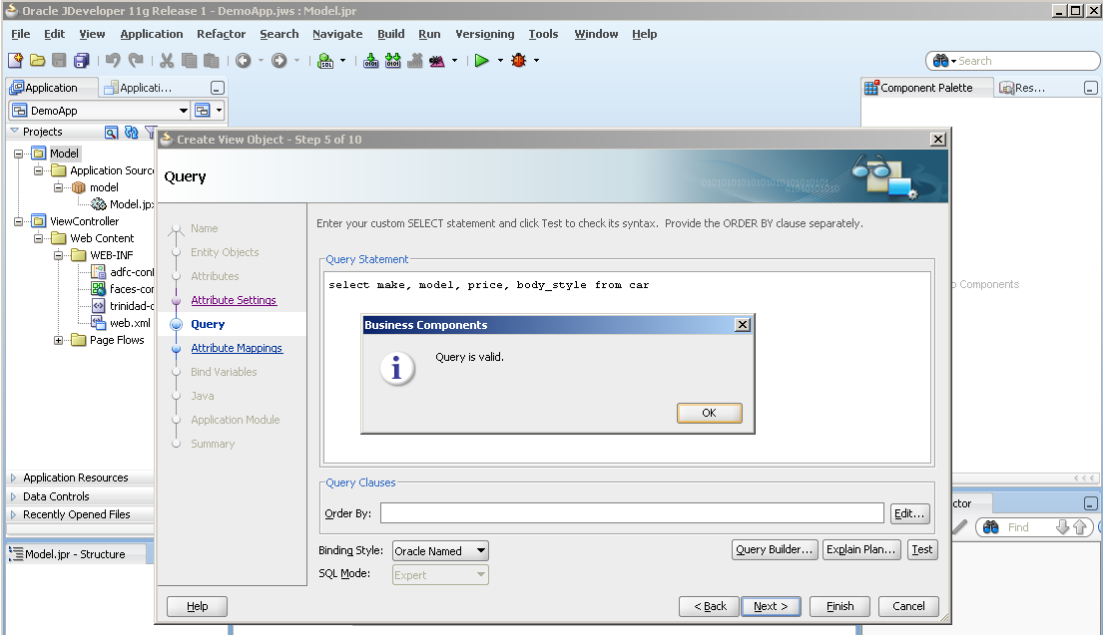

1. Here you see the columns the values for which the view object would fetch from the database. Click ‘Next’.

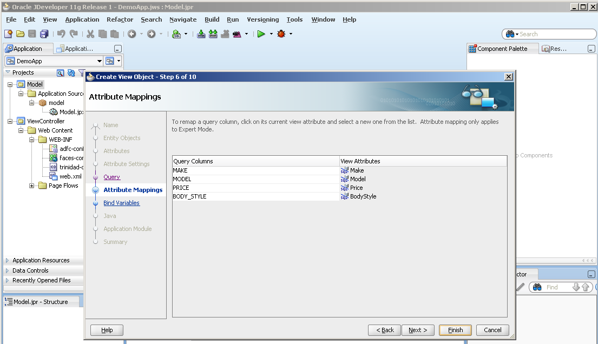

1. Click ‘Next’.

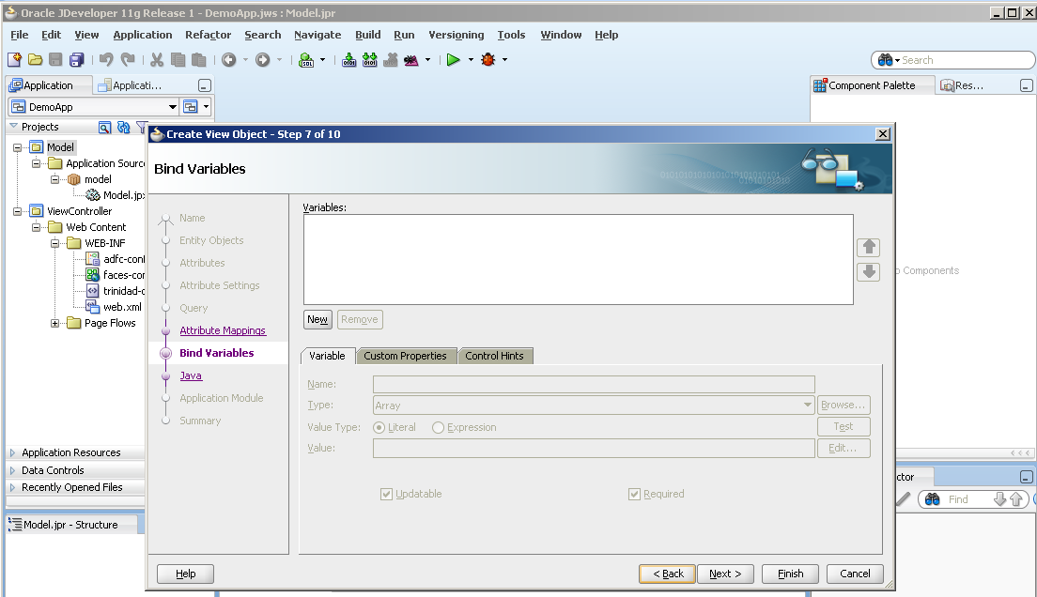

1. Click ‘Next’.

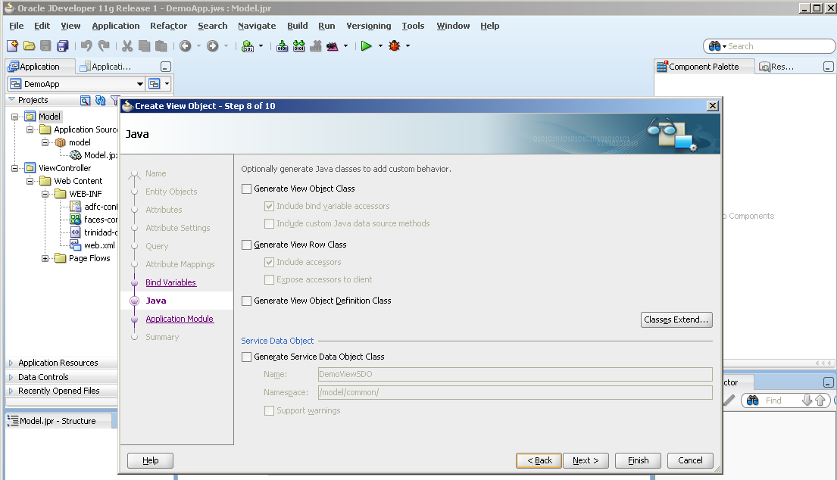

1. Check the ‘Application Module’ checkbox and click ‘Next’.

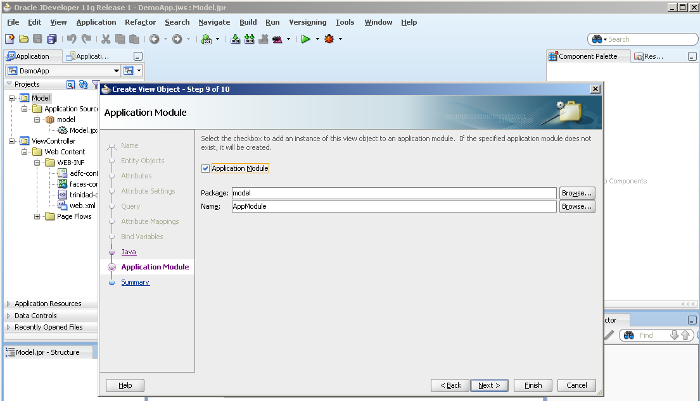

1. Click on ‘Finish’ to complete the business component creation.

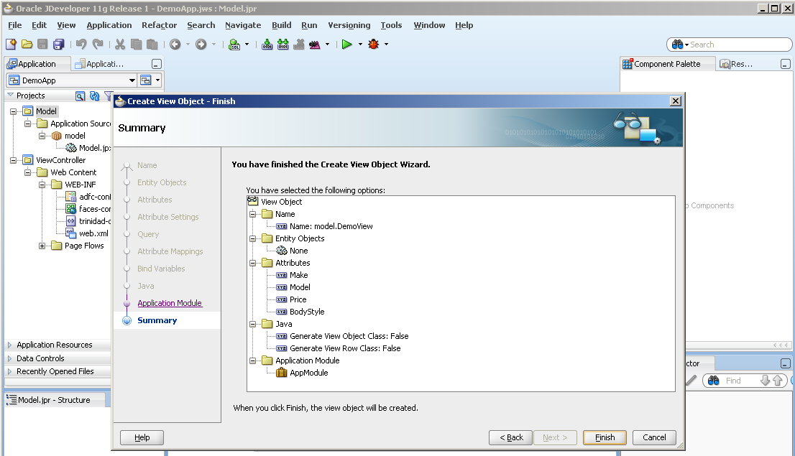

1. Notice the Application module and the View Object created in the Application Navigator.

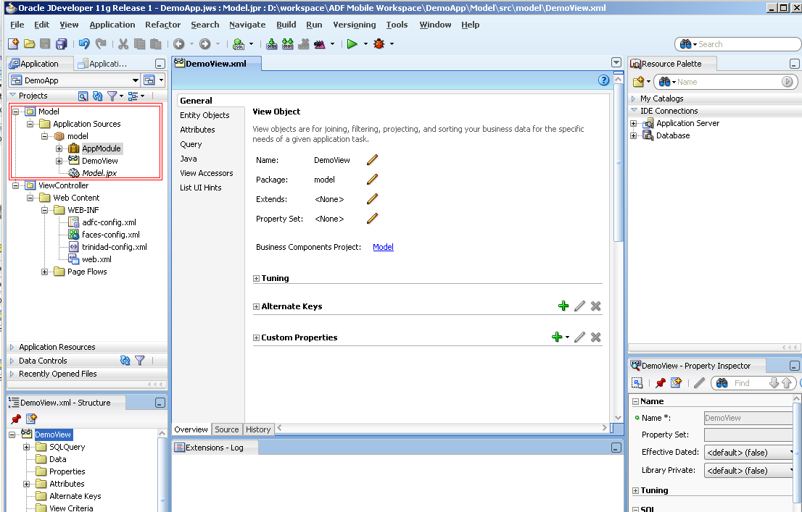

1. Right click on ‘AppModule’ and click on ‘Run’ to verify the successful working of the view object.

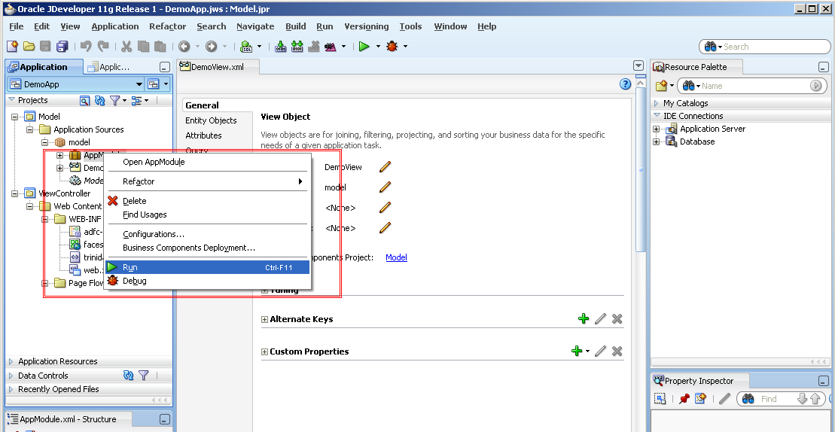

1. Notice the logs at the bottom while the Application module is being run.

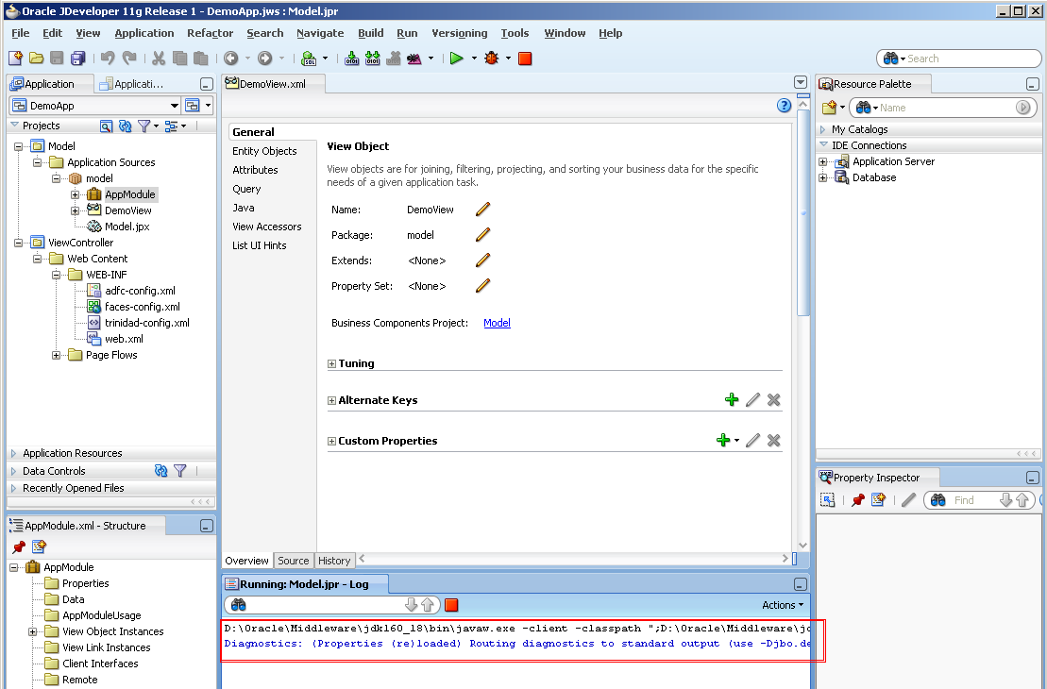

1. In the ‘Oracle Business Component Browser’ double click on the view object ‘DemoView1’.

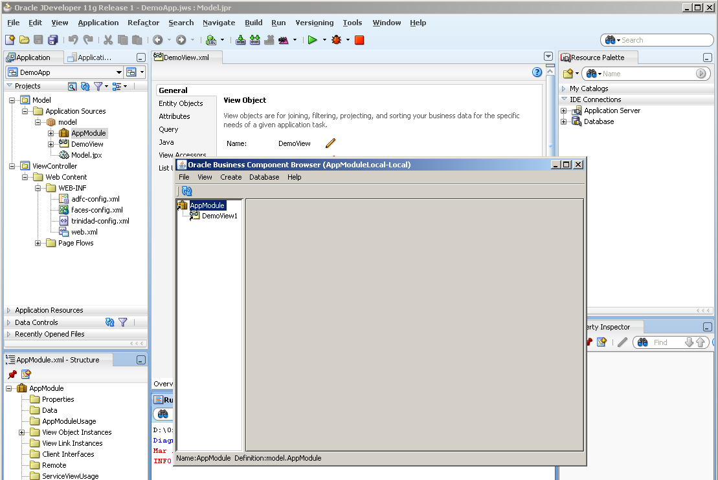

1. It will show the data for the columns required after fetching from the database. Click on ‘>’ to verify the results for next consecutive rows’ data.

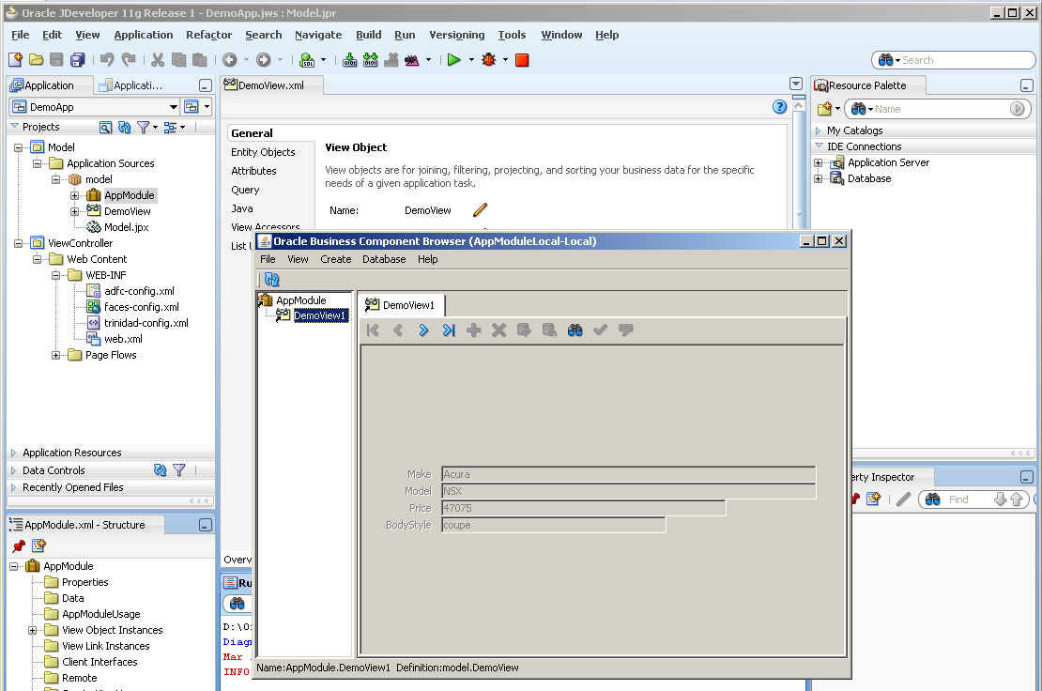

1. You can also right click on the View object and click on ‘Show Table’ to view the data retrieved in a tabular form.

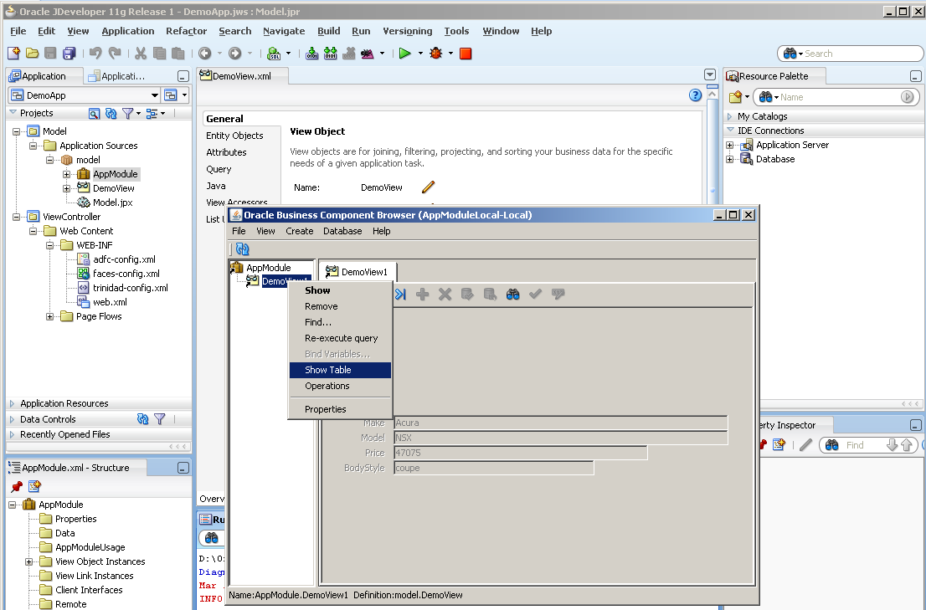

1. Verify the rows retrieved and close the box.

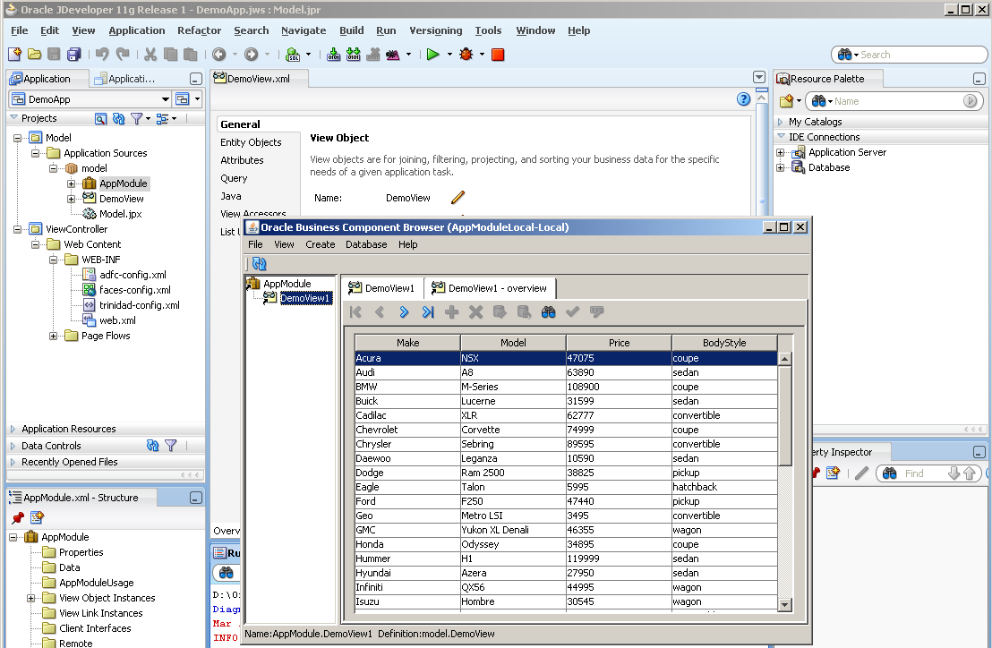

* 1. Creating the pages for user view

1. Double click on ‘faces-config.xml’ in the Application Navigator to open it. Drag a ‘JSF Page’ component from the component palette to the xml file.

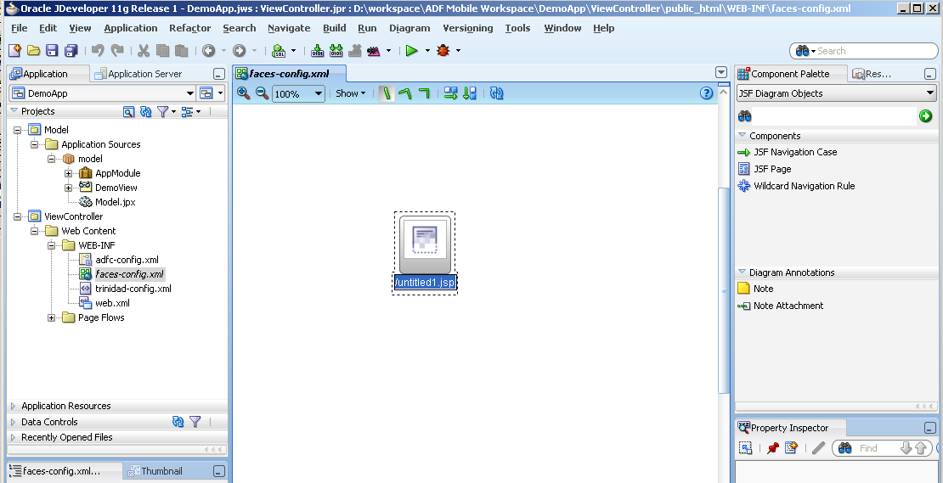

1. Name it as ‘Page1.jsp’.

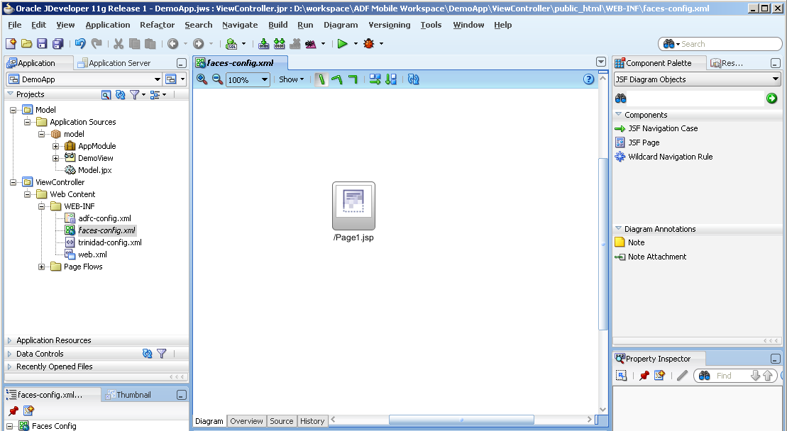

1. Similarly drag another ‘JSF Page’ and name it as ‘Page2.jsp’. Drag a ‘JSF Navigation Case’ and draw it from Page1 to Page2.

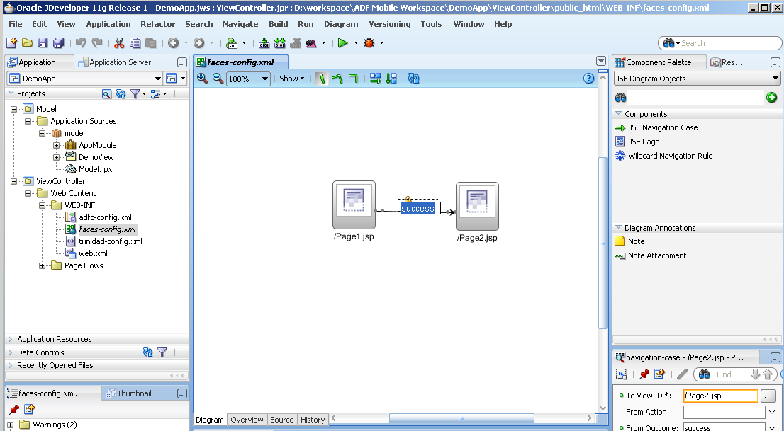

1. Double click on ‘Page1.jsp’ to create a corresponding jsp page. ‘Create JSF Page’ box opens. Ensure that the ‘Render in Mobile Device’ checkbox is checked. Click ‘OK’.

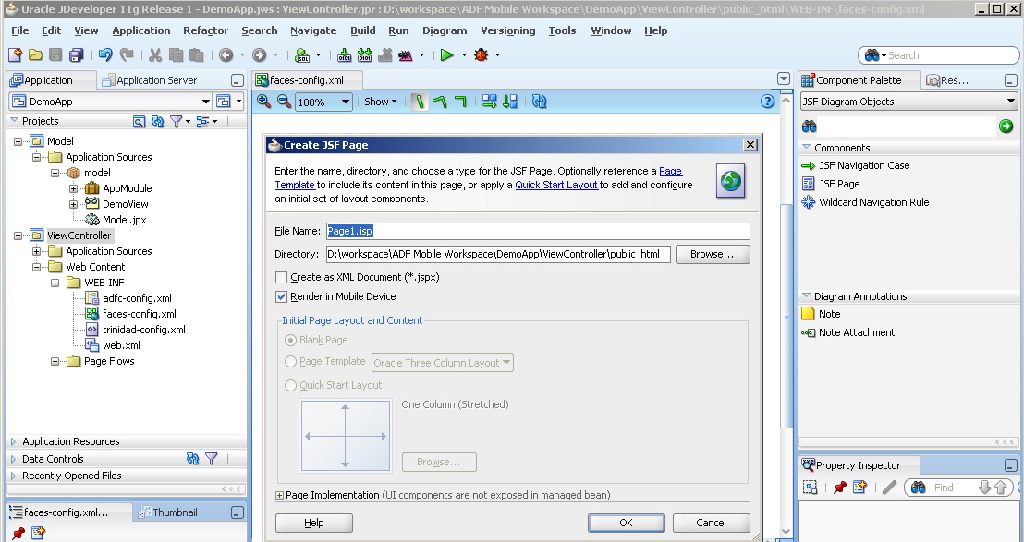

1. You will see Page1.jsp created. Make sure that the screen size is set to ‘240x320’.

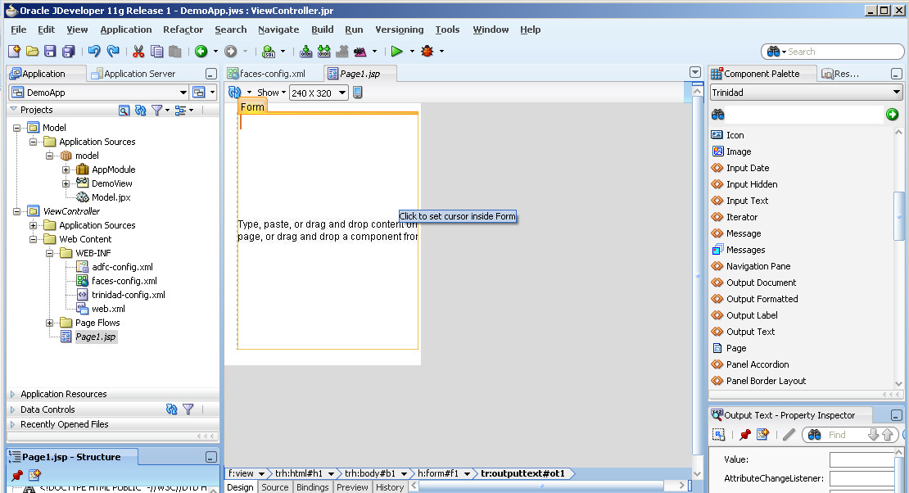

1. Drag a ‘Output Text’ component from the Component Palette (Ensure that you use the ‘Trinidad’ components). Enter the value as some text in the ‘Property Inspector’ below the ‘Component Palette’.

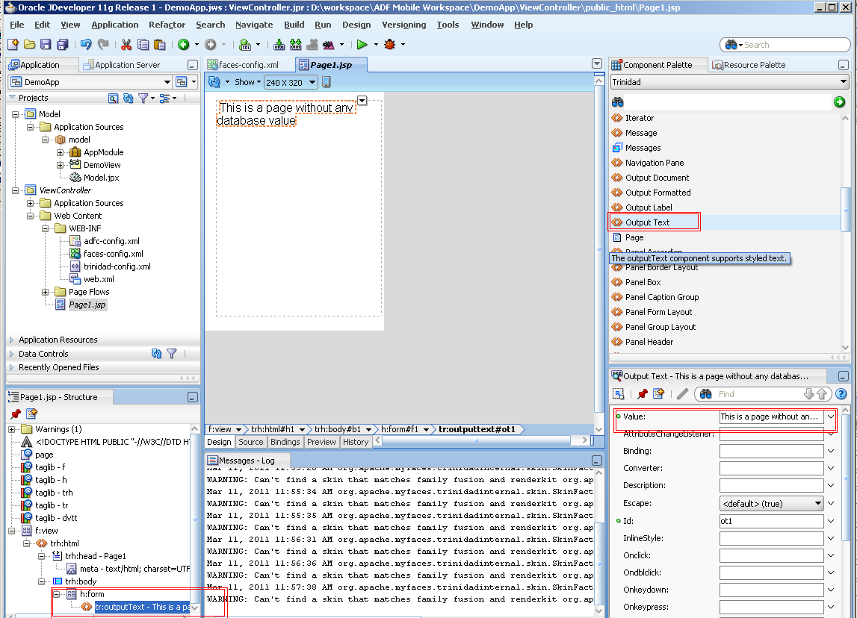

1. Drag a ‘Command Link’ component to the page. Enter its ‘Text’ property as ‘Link to page 2’ and ‘Action’ property value as ‘success’. Please make sure this action value is the same as was the label of navigation flow rule in faces-config.xml.

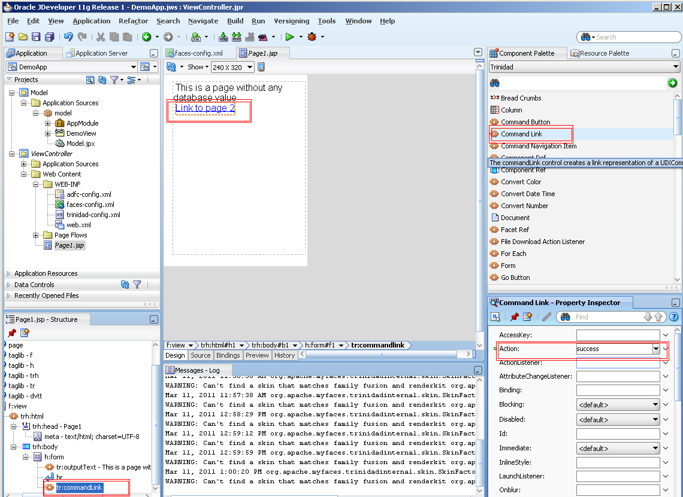

1. Go to ‘faces-config.xml’ and repeat the steps for ‘Page2.jsp’.

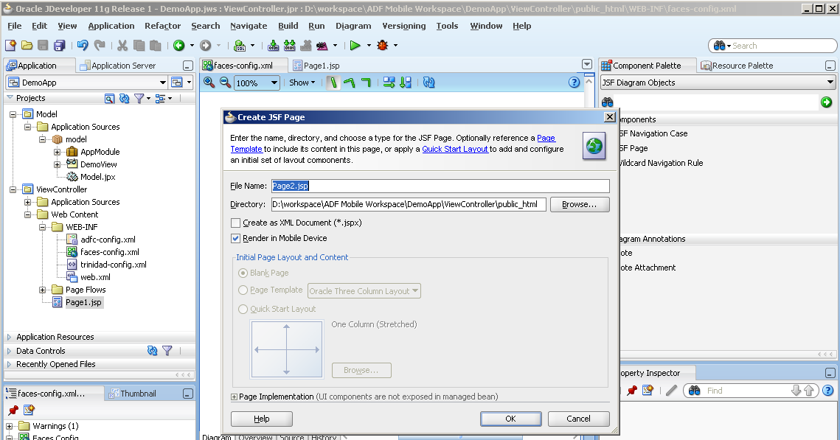

1. You will see Page2.jsp created. Drag the view object from the ‘Data Controls’ section and drop it on to ‘f:view’ in the Structure pane at the left bottom. Select Table -> Trinidad Read-only Table.

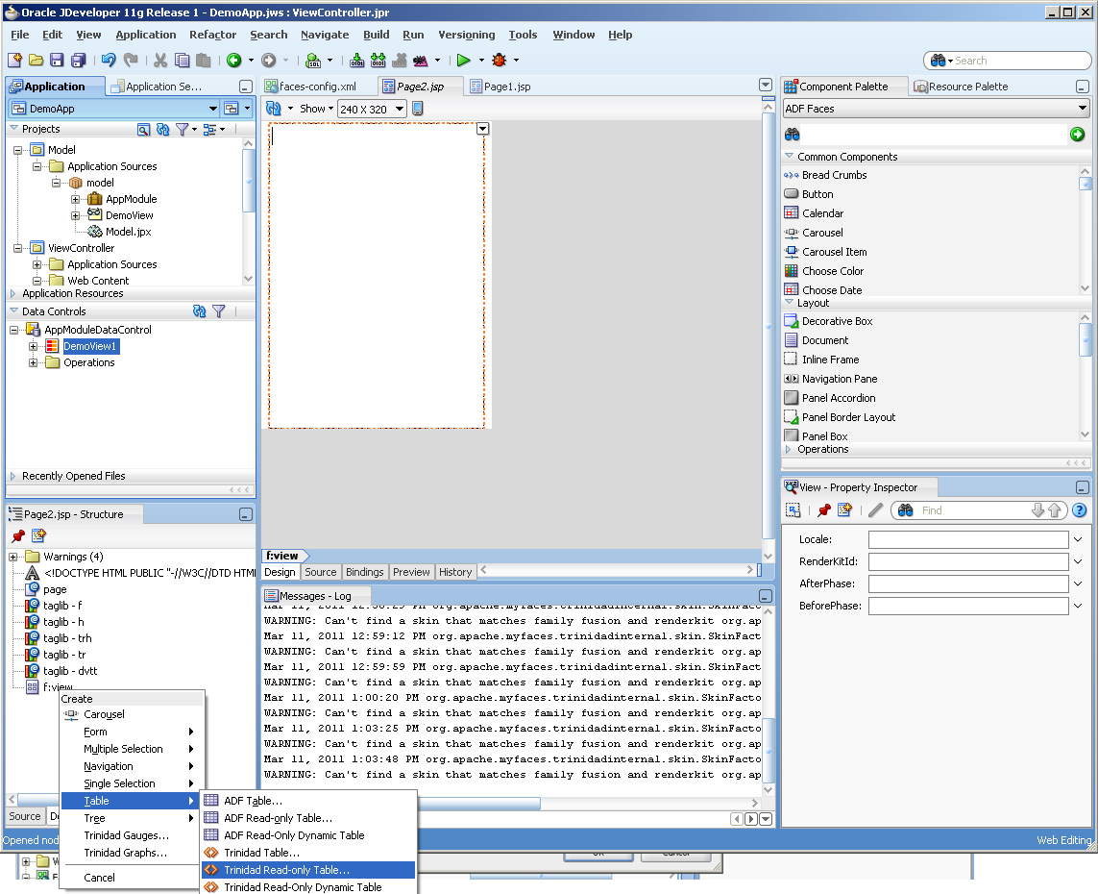

1. You will see the columns that will be displayed on the table in page. Click ‘OK’

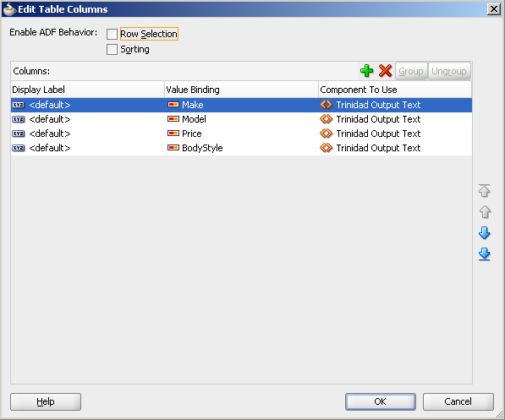

With this the creation of a simple ADF mobile browser based application concludes.

**PART 2: Deploying the application**

**Requirements:** Ensure that the web logic server is running

1. Right click on the application ‘DemoApp’, select ‘Deploy’ and click on ‘DemoApp_application1’ which is the deployment profile created by default for the application.

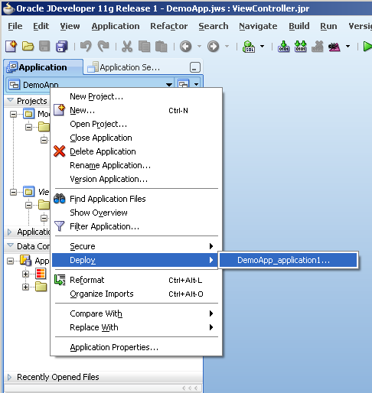

1. Select ‘Deploy to Application Server’. Click ‘Next’.

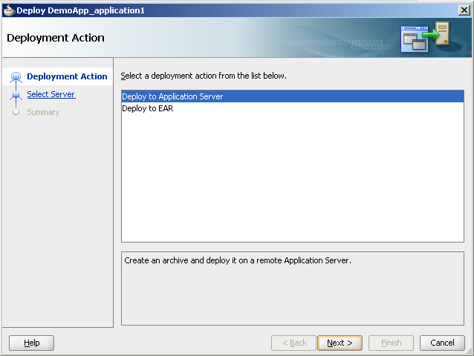

1. Select ‘IntegratedWeblogicServer’

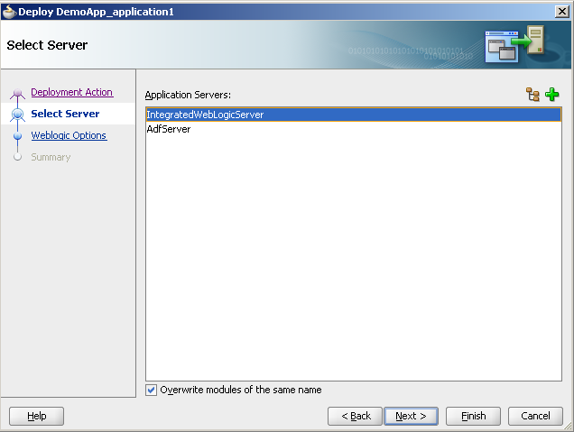

1. Select ‘Deploy to selected instances in the domain’ and then select ‘DefaultServer’. Click ‘Next’ and then click on ‘Finish’. Ensure that you get the success logs at the bottom in the ‘Deployment’ tab along with the link where the application can be accessed from.

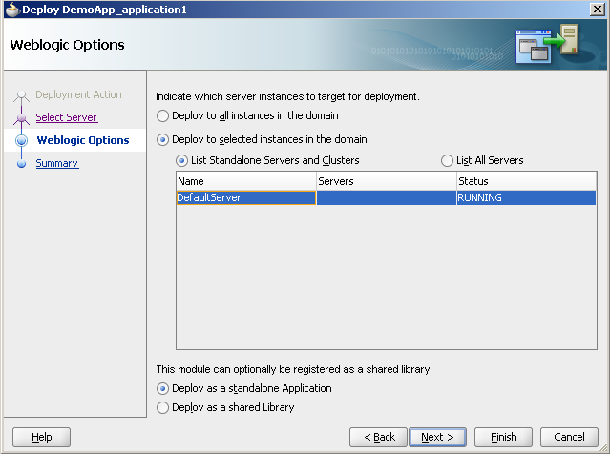

**PART 3: Running the application in the Blackberry 9700 simulator**

1. Go to Start -> All Programs -> Research in Motion -> Blackberry JDE 6.0.0 -> MDS-CS to start the simulator JDE environment. Please note that this is a necessary step to connect to the application through the simulator.

Go to Start -> All Programs -> Research in Motion -> Blackberry Smartphone Simulators 5.0.0 -> 9700 to start the simulator.

You will see the simulator screen opened as below. Go to ‘Browser’ icon on the screen. Type the URL as you get in the deployment logs in step 4 of Part 2.

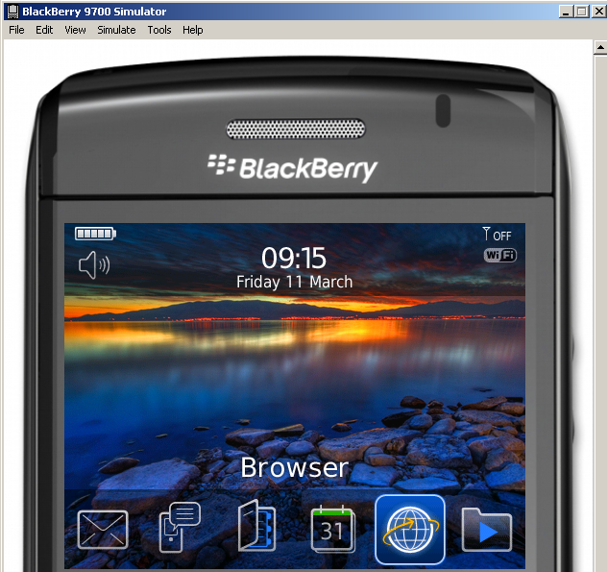

1. You will see the Page1 data displayed on the simulator screen. Click on ‘Link to page 2’ to verify the navigation to the second page.

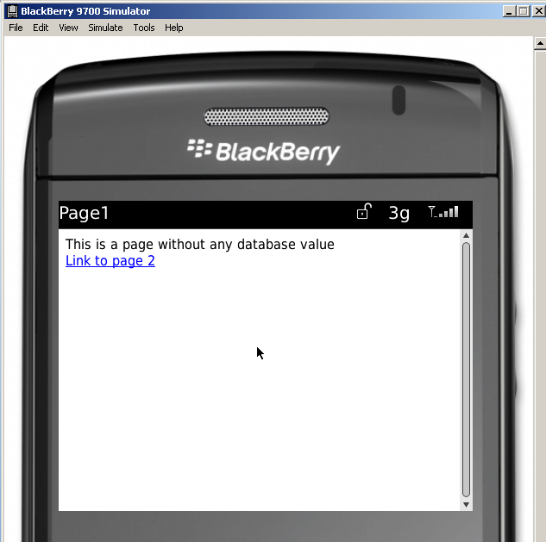

1. You will see the data in tabular form in the Page2.

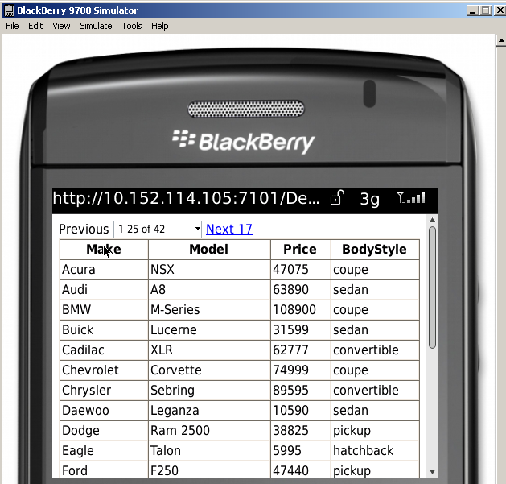

**References**

<http://www.oracle.com/technetwork/developer-tools/jdev/ccset51-all-102005.html>

<http://www.oracle.com/technetwork/developer-tools/adf/overview/adf-mobile-096323.html>